How to select some column from source

1. In sql:

Select empid, firstname, age, salary from employees

1. In workflows:
2. Create source similarly like previously created after that click on ‘+’

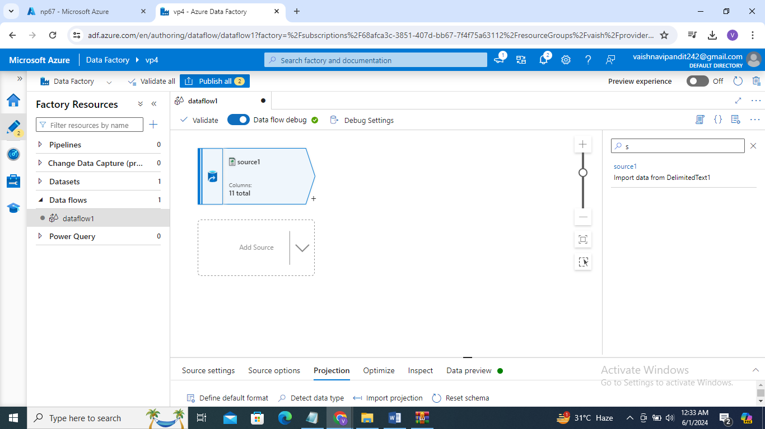

1. You will find select there click on that

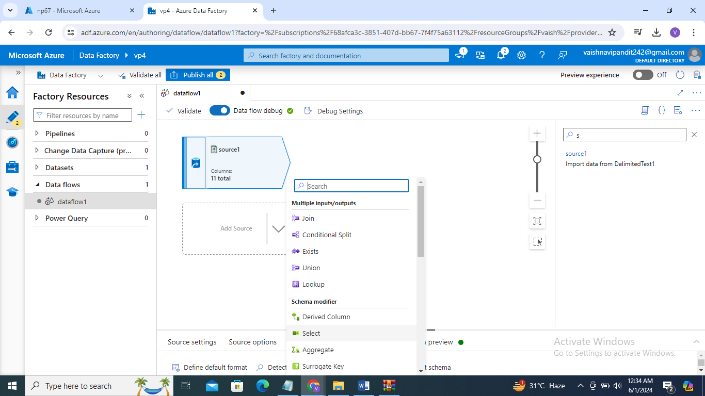

1. Go to select->settings

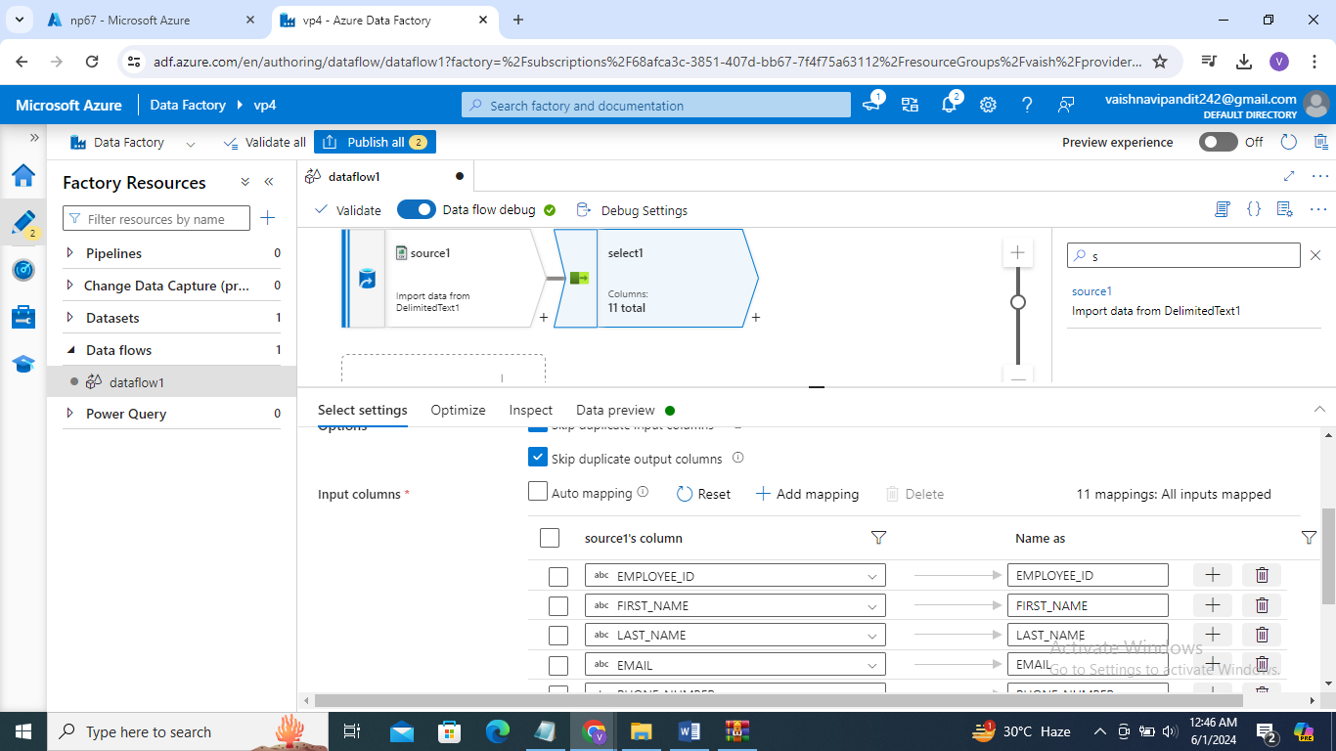

1. Go to input columns and deselect all the columns that you don’t want

And that’s how you select which columns you want

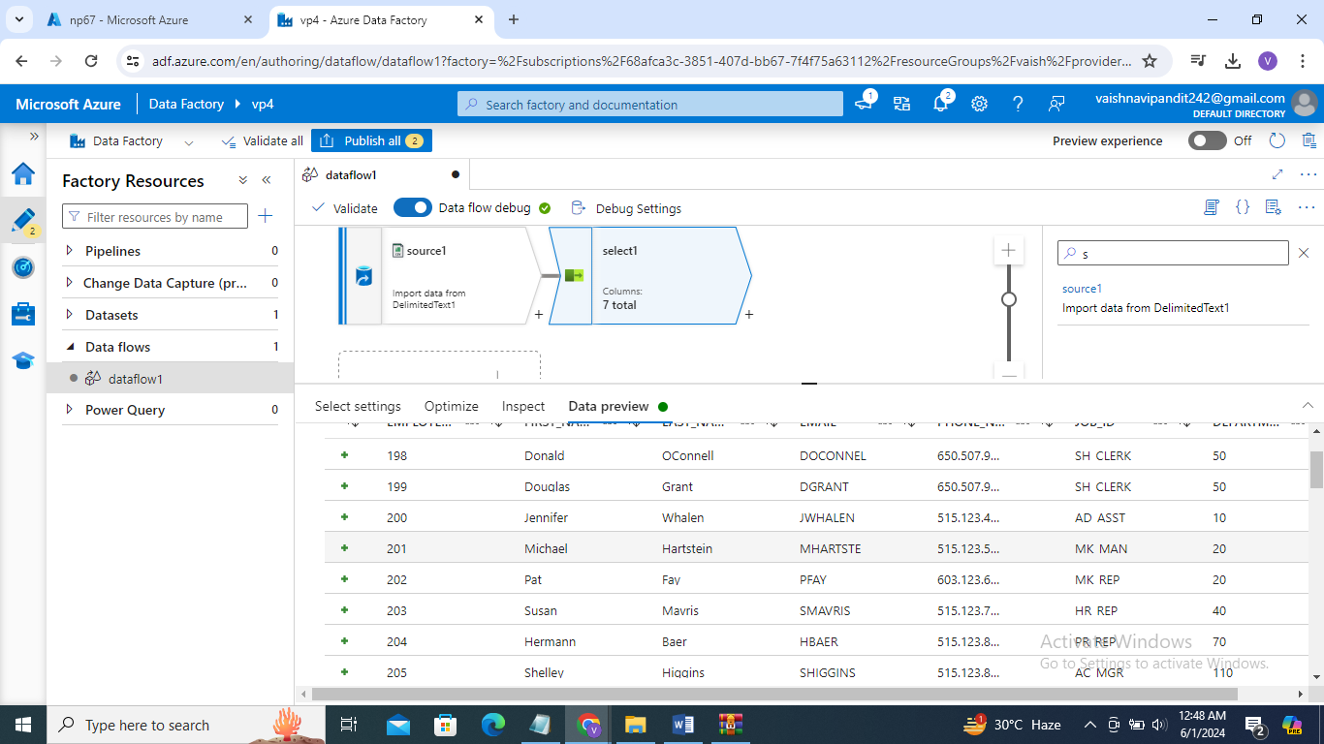

1. Now if you want to save in some folder then add sink this is called etl operation extract tansform and load

For extract we used source

Then for transformation select

Then for load sink

1. Go to +sign after select add sink

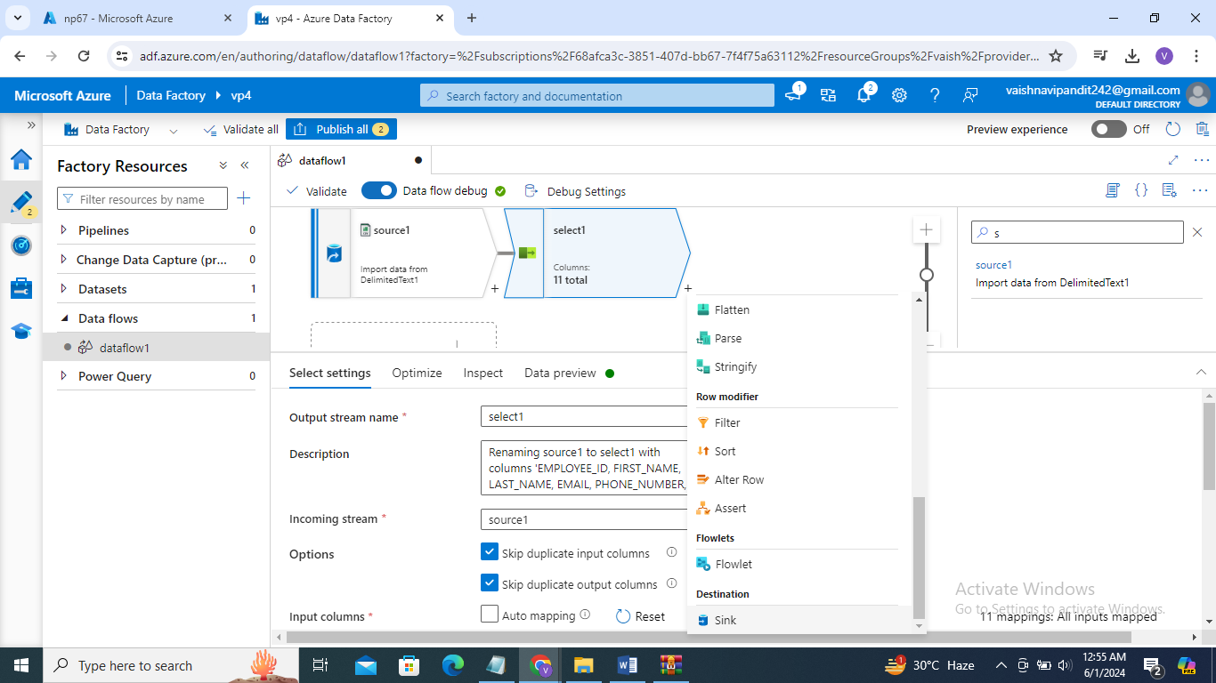

1. Add dataset where you want to save file in setting

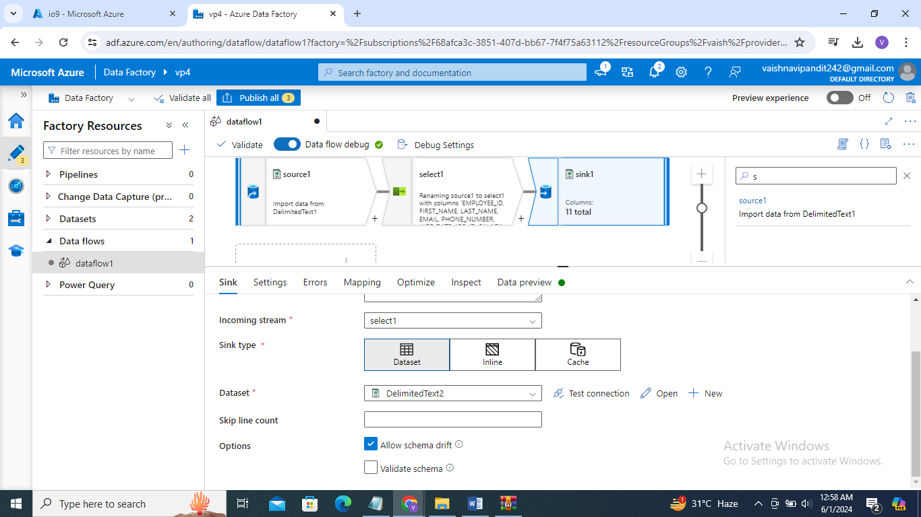

1. Now still you will debug this data will not be copied so go to the pipeline create pipeline

Go to move transform->select dataflow

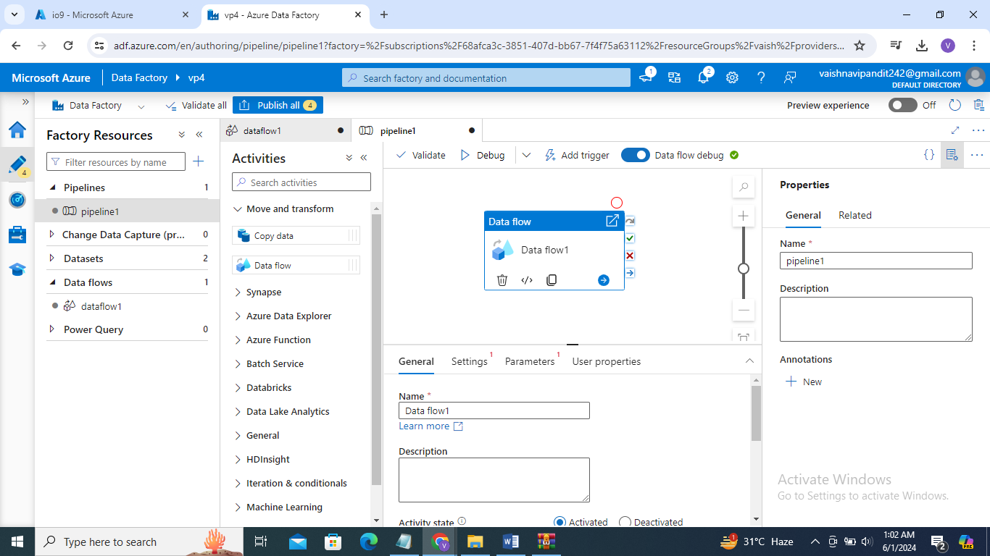

1. Go to settings

And select the dataflow that we created

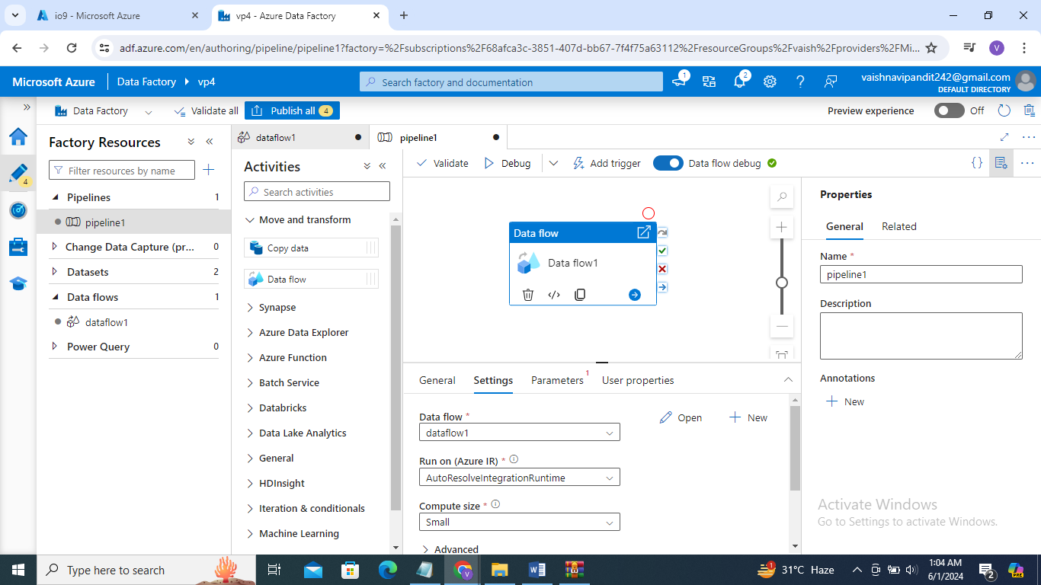

1. Publish and debug